Financial Forecasting

Developed By: Shubham Sangram Bej

Introduction
Financial forecasting is the process of estimating the future value of an investment based on a growth rate and time period. In this exercise, recursion and memoization are used to calculate future value efficiently.

Concept of Recursion
Recursion is a programming technique where a function calls itself to solve smaller instances of the same problem. Every recursive solution contains:

Base Case
The stopping condition that prevents infinite recursion.
if (years == 0){
return principal;
}

Recursive Case
The problem is reduced into a smaller version of itself.
return calculateFutureValueMemoized(
principal * (1 + rate),
rate,
years - 1
);
Recursion helps simplify complex problems by dividing them into smaller and more manageable sub-problems.

Advantages of Recursion
- Divide and Conquer approach
- Elegant and concise code
- Natural solution for hierarchical problems
- Easier representation of repeated calculations

Drawbacks of Recursion
- Higher memory consumption due to recursive call stack
- Risk of stack overflow for large recursion depth
- Can perform repeated calculations without optimization
- More difficult to debug compared to iterative solutions

Memoization
Memoization is an optimization technique where previously computed values are stored and reused.
In this implementation:
if (memo.containsKey(years)){
return memo.get(years);
}
The HashMap stores already calculated results, reducing unnecessary computations.

Time Complexity Analysis

Recursive Forecasting with Memoization
Operation | Complexity
Time Complexity | O(n)
Space Complexity | O(n)
Reason:
- Each value of years is calculated only once.
- Results are stored in the memoization map.
- Maximum recursion depth is n.

Alternative Optimizations

Iterative Approach
for(int i=0;i<years;i++)
principal *= (1 + rate);
Complexity:
Time : O(n)
Space : O(1)

Mathematical Formula
principal * Math.pow(1 + rate, years)
Complexity:
Time : O(1)
Space : O(1)
This is the most efficient solution for this specific forecasting problem.

Sample Output
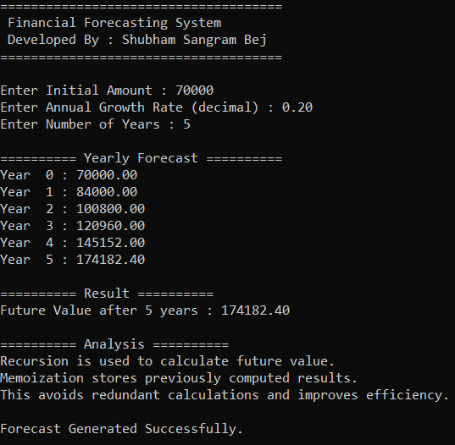

Conclusion
The Financial Forecasting System successfully predicts future investment value using recursion and memoization. The recursive approach demonstrates problem decomposition, while memoization introduces optimization techniques. Although iterative and formula-based solutions can be more efficient for this specific problem, recursion remains valuable for understanding recursive problem-solving concepts.

